**Route 53 Section [Global]**

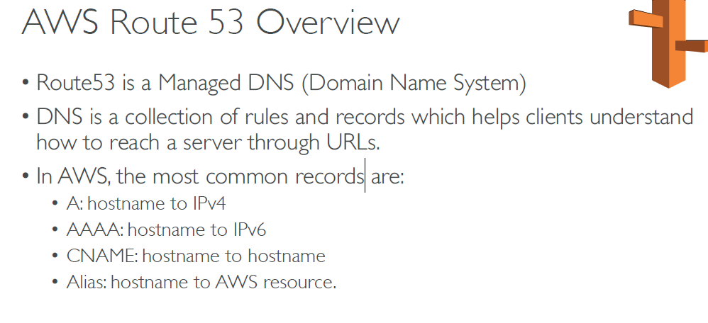

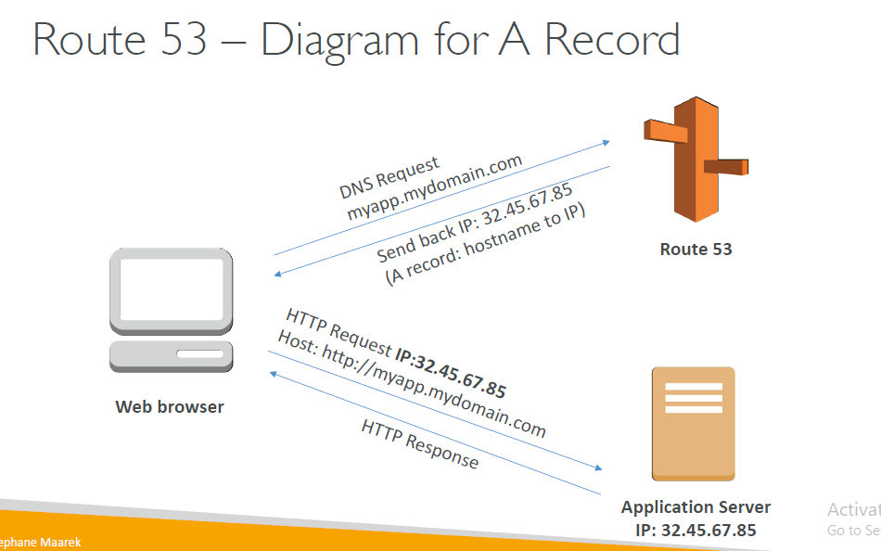

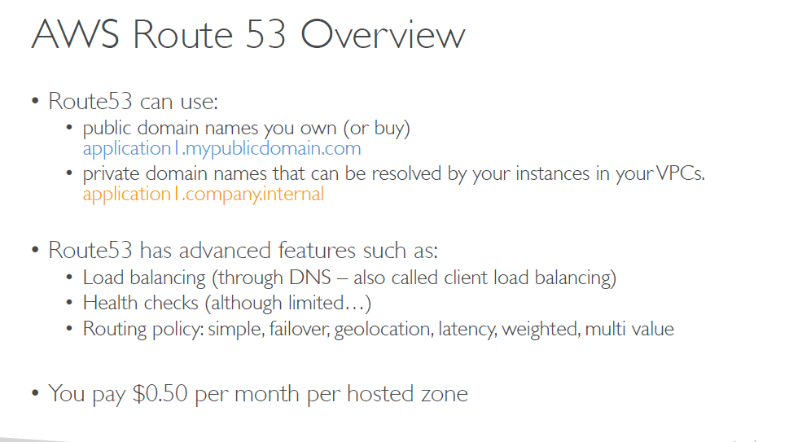

**Route 53 Hands On**

* Create the domain [Route53 ….Register domain]
* Go to Hosted zone…select the domain name which created….& create Record set.
  + Nameof the record: myfirst.domainname.com Type:IPV4/IPV6/CNAME/ALIAS

TTL value: 300s

* + Value: Mention the Ip addres to route
  + Verfy in DNS record CLI
  + # nslookup myfirst.domainname.com
  + It routes to your mentioned IP

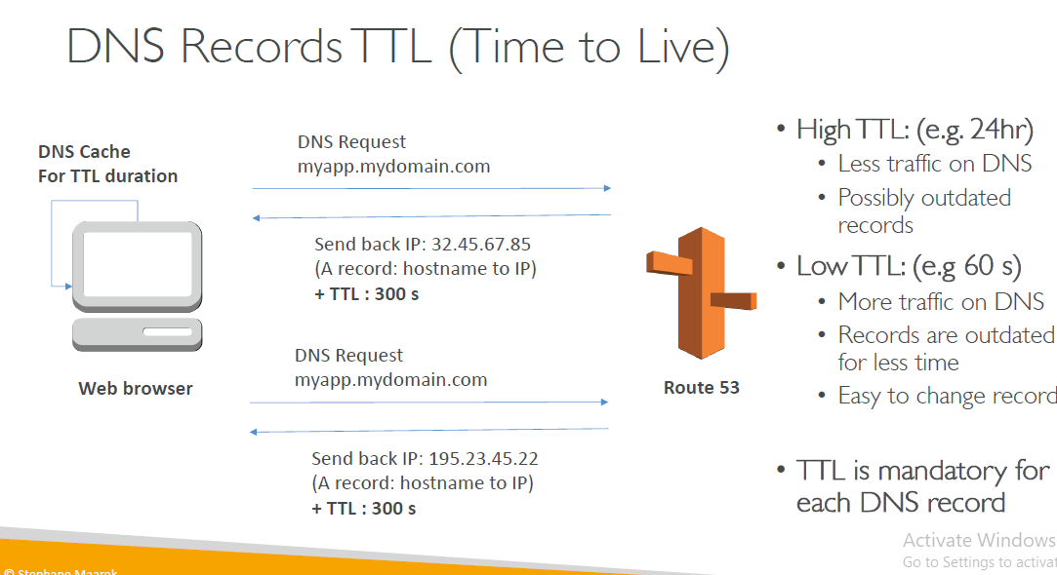

TTL is mandatory for each DNS record Def: 300s

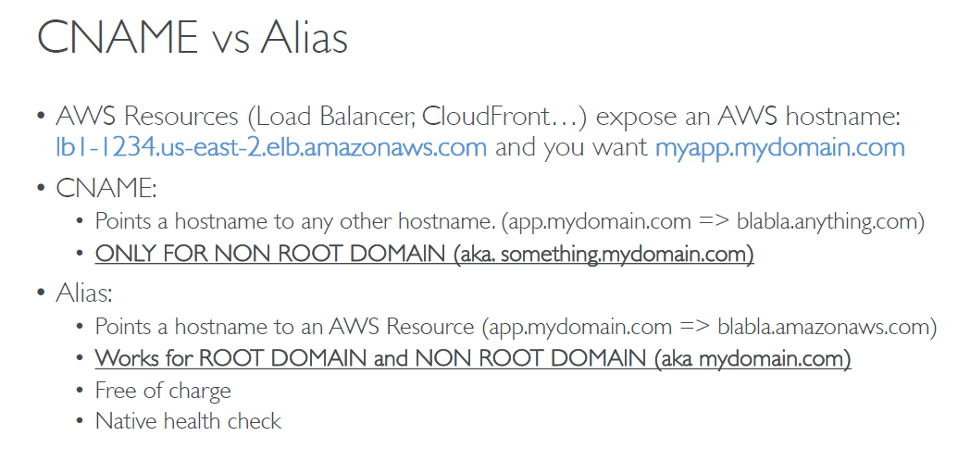

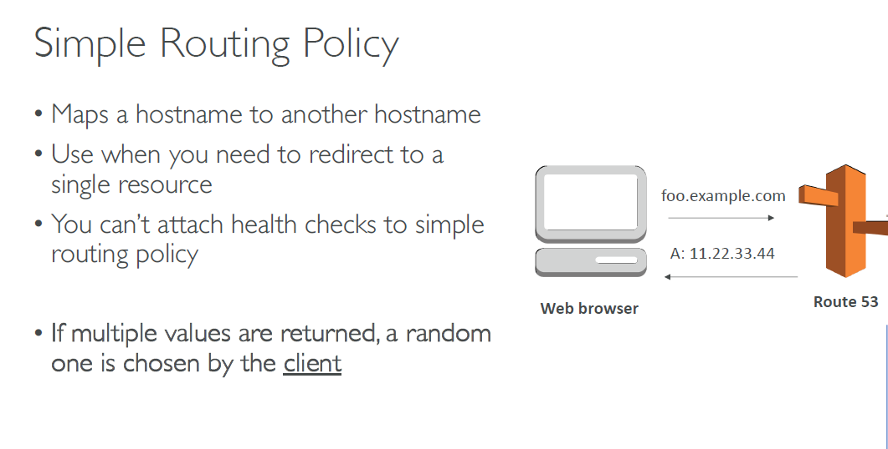

Hands On

Create Record

Name: myhost.domainname.com

Type: Arecord

TTL: 60 sec

Routing policy: simple

Value: ipaddress1

Ipdreass2

Ipadders3 you can give multiple ip when u hit the domain address it will receive all 3 ip address back , the brouser [client load balancing] will choose the which IP to go & it stays to that for TTL period 60sec.

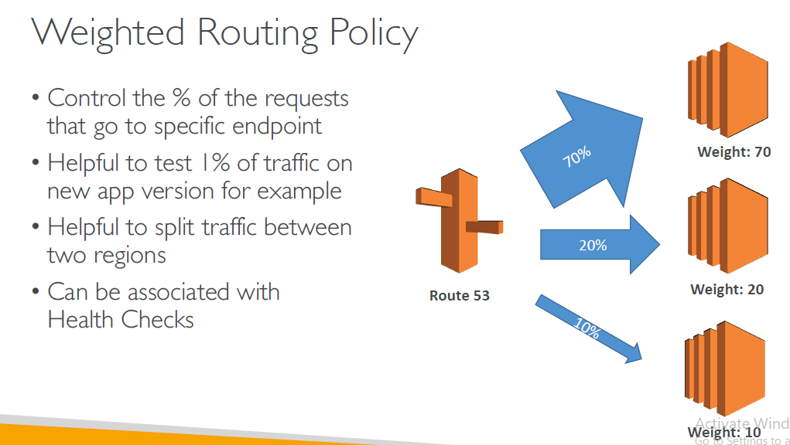

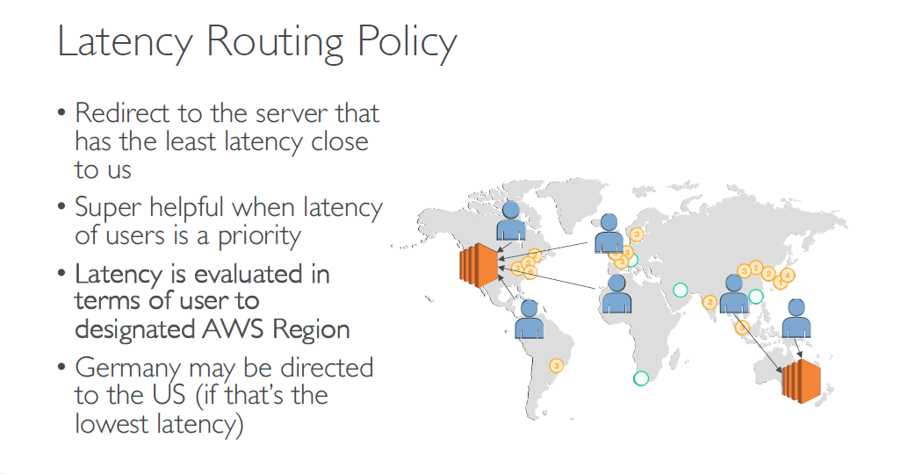

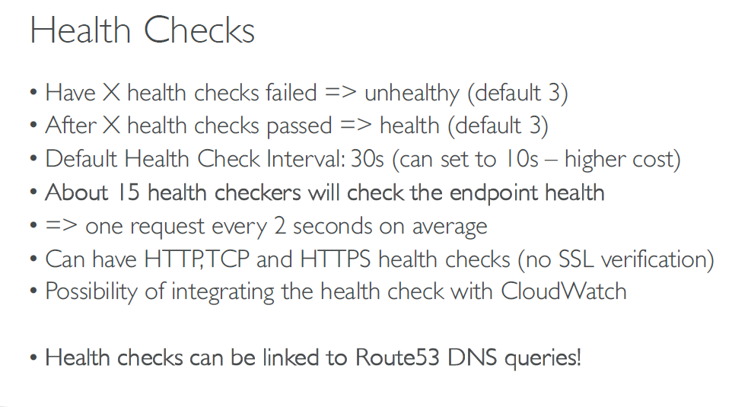

Heath check Hands ON

Route53 …..Health checks…Create

Name:

What to monitor: Eendpoint/ state of clount watch alarm

Endpoint: IP or dns

Protocol: http

IP address: mention the EC2 ipaddress

Port: 80 path

